PROJECT REPORT
PROJECT TITLE: SOCIAL MOOD MATCHER TEAM ID: SWTID-2026-7822
TEAM LEADER: PAVITHRA.R
TEAM MEMBER: KAVIYA.R
TEAM MEMBER: DHANU SRI.G
TEAM MEMBER: YUVA SRI.E

CHAPTER 1: INTRODUCTION
1.1 Overview
In recent years, social media platforms have become one of the most powerful communication tools used by people all around the world. Millions of users share their thoughts, opinions, and feelings through text posts, comments, and messages. These expressions often reflect the emotional state or mood of the user at a given moment.
The Social Mood Matcher project aims to analyse these emotions using computational techniques and match users who share similar emotional states. This project uses Natural Language Processing (NLP) and Machine Learning algorithms to identify mood patterns from textual data.
By matching users based on their emotional state, the system helps create meaningful social connections. It can also be useful for community building, emotional support systems, and mental health awareness.
1.2 Need for the System
People often express their emotions online but rarely find individuals who truly understand how they feel at that moment. Many existing systems recommend users based on interests or social networks rather than emotional similarity.
The Social Mood Matcher system is needed because: • Users want meaningful connections.
• Emotional understanding improves communication. • Mental health awareness is increasing.
• Social platforms need smarter interaction systems.
• This system allows users to find people who share similar moods, creating a supportive and empathetic digital
environment.
1.3 Goals of the Project
The primary goal of this project is to develop an intelligent system capable of detecting emotions from textual input and matching users accordingly.
The main goals include:
• Designing a mood detection algorithm.
• Implementing sentiment analysis techniques.
• Creating a user-friendly interface.
• Matching users with similar emotional states.
• Enhancing social interaction and engagement.
1.4 Project Motivation
The motivation behind this project comes from the increasing role of artificial intelligence in understanding human behaviour. Emotion recognition technology has become an important research area.
By analysing emotional data from social media posts, researchers and developers can gain valuable insights into public mood trends. The Social Mood Matcher system aims to apply this technology to create better online communities.

CHAPTER 2: LITERATURE REVIEW

2.1 Introduction
The literature review provides an overview of previous research conducted in the field of sentiment analysis, emotion detection, and social media data analysis.
Researchers have explored different techniques for identifying emotions in text. These techniques include rule-based systems, machine learning algorithms, and deep learning models.
2.2 Sentiment Analysis Techniques
Sentiment analysis is a computational method used to identify and classify emotions in text data.
There are three main types:
1. Rule-Based Approach
This approach uses predefined rules and dictionaries to detect sentiment.
Advantages:
• Simple to implement
• No training data required
Disadvantages:
• Limited accuracy
• Cannot understand complex expressions

2. Machine Learning Approach
Machine learning algorithms are trained using labelled datasets. Common algorithms include:
• Naive Bayes
• Support Vector Machine
• Decision Tree
Advantages:
• Higher accuracy
• Can learn patterns from data
Disadvantages:
• Requires training datasets
3. Deep Learning Approach
Deep learning uses neural networks to analyse complex patterns in text.
Examples include:
• Recurrent Neural Networks
• Long Short-Term Memory (LSTM)
• Transformer models
Deep learning provides better results for emotion detection.

2.3 Emotion Detection Models
Emotion detection models classify text into emotional categories. Common emotional categories include:
• Happiness
• Sadness
• Anger
• Fear
• Surprise
• Neutral
These models analyse linguistic patterns and contextual meaning.

CHAPTER 3: SYSTEM ANALYSIS

3.1 Existing System
Existing systems in social media platforms mainly focus on recommending content based on user interests, browsing history, and engagement.
Examples include:
• Friend recommendations
• Content suggestions
• Trending posts
However, these systems do not consider emotional states.
3.2 Drawbacks of Existing System
The limitations include:
• Lack of emotional awareness
• No mood-based matching
• Limited emotional support for users
• Reduced meaningful interaction
3.3 Proposed System
The proposed system introduces a Social Mood Matcher that identifies the emotional state of users through text analysis and matches them with others who have similar emotional expressions.
Key features include:
• Mood detection
• User matching algorithm • Real-time emotion analysis • User-friendly interface

CHAPTER 4: SYSTEM ARCHITECTURE

4.1 Architecture Overview
The system architecture consists of several components working together to analyse user data and produce mood matching results.
Main components include:
1. User Interface
2. Text Processing Module
3. Emotion Detection Module
4. Mood Matching Algorithm
5. Database System
4.2 Working Process
The system works in the following steps:
1. User enters text input.
2. Text is reprocessed.
3. Emotion is detected using sentiment analysis.
4. Mood category is assigned.
5. Users with similar moods are matched.

CHAPTER 5: DATA PREPROCESSING

5.1 Introduction
Data preprocessing is an essential step in any Natural Language Processing system. Raw text data collected from users often contains unnecessary words, punctuation marks, symbols, and formatting issues. These elements can affect the accuracy of the sentiment analysis process. Therefore, preprocessing helps in cleaning and preparing the data before it is analysed by the machine learning model.
The main objective of preprocessing is to convert unstructured text data into a structured format that can be easily processed by the system. Proper preprocessing improves the performance and reliability of the mood detection system.
5.2 Text Cleaning
Text cleaning is the first stage in data preprocessing. It removes unnecessary characters such as punctuation marks, special symbols, and numbers that do not contribute to sentiment detection.
Examples of removed elements:
• Special characters
• Extra spaces
• URLs
• Emojis (optional)
After cleaning, the text becomes simpler and easier to analyse.
Example:
Original text:
"I am very happy today!!!
Cleaned text:
"I am very happy today"
5.3 Tokenization
Tokenization is the process of splitting text into individual words or tokens. This allows the system to analyse each word separately.
Example:
Sentence:
"I feel excited about this project"
Tokenized output:
[I, feel, excited, about, this, project]
Tokenization is important because machine learning algorithms process text in the form of tokens.
5.4 Stop Word Removal
Stop words are common words that appear frequently in sentences but do not carry significant meaning in sentiment analysis.
Examples of stop words include:
• is
• the
• and
• a
• to
• in
Removing these words helps reduce data size and improve processing efficiency.
Example:
Input:
"I am feeling very happy today"
Output:
[feeling, happy, today]
5.5 Stemming and Lemmatization
Stemming reduces words to their root form by removing suffixes. Example:
playing → play
running → run
happiness → happy
Lemmatization is a more advanced technique that converts words into their base dictionary form.
Example:
better → good
running → run
Both techniques help the system recognize different forms of the same word.

CHAPTER 6: MOOD CLASSIFICATION

6.1 Introduction
Matcher system. In this stage, the system analyses processed text data Mood classification is the core functionality of the Social Mood and identifies the emotional state of the user.
The classification process uses machine learning models trained on labelled datasets. These datasets contain examples of text associated with specific emotions.
The system learns patterns from this training data and uses them to classify new user inputs.
6.2 Mood Categories
The system classifies user emotions into several categories. These categories represent common emotional states expressed by individuals.
Common mood categories include:
• Happy
• Sad
• Angry
• Excited
• Neutral
Each category represents a different emotional tone that can be identified through textual expressions.
6.3 Machine Learning Algorithms
Machine learning algorithms play an important role in mood classification.
Commonly used algorithms include:
Naive Bayes
A probabilistic classifier that works well for text classification tasks. It calculates the probability of a text belonging to a particular mood category.
Support Vector Machine
This algorithm identifies patterns in high-dimensional data and separates different mood categories using decision boundaries.
Decision Tree
Decision trees classify text data by creating a tree-like structure based on decision rules.
Each algorithm has its own advantages and can be selected based on system requirements.
6.4 Training the Model
Before the system can classify moods accurately, the machine learning model must be trained using labelled data.
Training involves:
1. Providing sample text data
2. Assigning emotion labels
3. Teaching the algorithm to recognize patterns
Once trained, the model can predict the mood of new user inputs.

CHAPTER 7: MATCHING ALGORITHM
7.1 Introduction
The matching algorithm is responsible for connecting users who share similar emotional states. After detecting the mood of each user, the system compares emotional categories and identifies potential matches.
The algorithm ensures that users are recommended to others who are experiencing similar feelings.
7.2 Matching Process
The matching process includes several steps:
1. Detect the mood of the user.
2. Store the mood category in the database.
3. Compare the mood with other users in the system.
4. Identify users with the same emotional category.
5. Recommend those users as potential matches.
This process helps create emotionally supportive connections.
7.3 Similarity Measurement
To improve accuracy, the system can measure similarity between emotional expressions using text similarity techniques.
Examples include:
• Cosine similarity
• Euclidean distance
• Semantic similarity

CHAPTER 8: USER INTERFACE DESIGN
8.1 Introduction
The user interface is the visual part of the system that allows users to interact with the application. A well-designed interface improves user experience and makes the system easy to use.
The interface should be simple, responsive, and visually appealing.
8.2 Main Interface Components
The Social Mood Matcher interface includes several components: • Login page
• Mood input page
• Mood analysis result page
• Match recommendation page
Each component plays an important role in the user interaction process.
8.3 User Interaction Flow
The interaction flow of the system is as follows:
1. User logs into the system.
2. User enters a message describing their current mood. 3. System analyses the message.
4. Mood result is displayed.
5. System recommends users with similar moods.
This process ensures smooth user interaction.

CHAPTER 9: TESTING
9.1 Importance of Testing
Testing is an important stage in software development. It ensures that the system functions correctly and meets user requirements.
Testing helps identify errors, improve performance, and increase reliability.
9.2 Types of Testing
Unit Testing
Unit testing focuses on testing individual components of the system. Each module is tested separately to verify its functionality.
Integration Testing
Integration testing ensures that different modules of the system work together correctly.
System Testing
System testing evaluates the complete application to ensure that it performs as expected.
9.3 Performance Testing
Performance testing evaluates how the system performs under different workloads. It checks whether the system can handle multiple users simultaneously without delays.

CHAPTER 10: RESULTS
10.1 System Output
The Social Mood Matcher system successfully analyses user text input and identifies the emotional state of the user. Based on the detected mood, the system recommends users who share similar emotional patterns.
The output is displayed clearly through the user interface.
10.2 Performance Evaluation
The performance of the system can be evaluated using metrics such as:
• Accuracy
• Precision
• Recall
• F1 Score
These metrics help determine the effectiveness of the mood classification algorithm.

CHAPTER 11: FUTURE ENHANCEMENT(DETAILED)
11.1 Introduction
Although the Social Mood Matcher system effectively detects moods and matches users based on emotional states, there are several areas where the system can be enhanced. Technology evolves rapidly, and user expectations continue to grow. By incorporating advanced features, the system can provide a more immersive and interactive user experience.
The future enhancements aim to improve the accuracy of mood detection, broaden the range of emotions, increase user engagement, and integrate with emerging technologies.
11.2 Voice-Based Mood Detection
Currently, the system analyses text input only. One major enhancement would be voice-based emotion recognition, where users can speak instead of typing.
Key points:
• Analyse tone, pitch, and speech patterns to detect emotions. • Can identify stress, excitement, or sadness in voice. • Helps visually impaired users interact with the system.
• Can be combined with text analysis for multimodal mood detection.
11.3 Image and Facial Emotion Recognition
Another enhancement is image-based mood detection using facial expression analysis.
Key points:
• Users can upload selfies or profile pictures.
• AI models detect emotions like happiness, sadness, anger, fear, or surprise.
• Combined with text and voice data, this provides a more accurate mood profile.
• Useful for mental health monitoring and social awareness applications.
11.4 Real-Time Mood Tracking
Introducing real-time mood tracking can greatly improve the system’s engagement.
• Monitor user mood continuously during online activity.
• Provide instant recommendations or alerts if mood changes drastically.
• Can integrate with chat applications for dynamic social matching.
• Useful for building mood-based communities and support groups.
11.5 Integration with Social Media Platforms
The system can be integrated with popular social media platforms such as Facebook, Twitter, Instagram.
• Automatically analyse public posts and comments. • Provide mood-matched friend suggestions.
• Increase system reach and usability.
• Helps social media companies improve user engagement.
11.6 Mobile Application Development
Developing a mobile app version of Social Mood Matcher will enhance accessibility.
• Users can check their mood on the go.
• Push notifications for mood updates.
• Easy communication with matched users.
• Integration with mobile sensors (camera, microphone) for multimodal mood detection.
11.7 Artificial Intelligence Chatbot Integration
A future enhancement could involve an AI-powered chatbot. • Chatbot interacts with users, detects mood from conversations. • Provides recommendations for positive interactions. • Offers mental health tips based on detected emotions. • Can act as a support system for emotionally distressed users.
11.8 Multi-Language Support
Currently, the system may support only English. Adding multi language support allows more global users to interact effectively.
• NLP models trained for different languages.
• Text analysis can detect emotions in regional languages. • Improves inclusivity and usability across different regions.
11.9 Predictive Mood Analysis
By incorporating machine learning predictive models, the system can anticipate user moods based on historical data.
• Helps in proactive recommendations.
• Alerts for potential negative moods.
• Can suggest activities or connect users before they feel lonely or sad.
• Useful for mental health monitoring and social support initiatives.11.10 Summary
Future enhancements aim to make the Social Mood Matcher system: • Smarter (accurate mood detection)
• Interactive (voice, image, chatbot)
• Accessible (mobile, multi-language)
• Proactive (predictive analysis)
• Socially impactful (integration with social media and support communities)
These enhancements will not only improve user experience but also increase the system’s relevance in modern digital communication and mental health support.

CHAPTER 12: CONCLUSION (DETAILED)
12.1 Overview
The Social Mood Matcher project demonstrates how artificial intelligence, natural language processing, and machine learning can be used to analyse human emotions in digital communication. By detecting moods from text inputs, the system provides meaningful connections between users experiencing similar emotional states.
This project emphasizes the importance of emotion-aware technologies in enhancing social interactions and online communication.
12.2 Achievements of the Project
The Social Mood Matcher successfully:
1. Collects user text input and preprocesses it for analysis. 2. Detects emotional states using machine learning algorithms.
3. Categorizes moods such as happy, sad, angry, excited, and neutral.
4. Matches users based on mood similarity.
5. Provides a simple and interactive user interface.
6. Offers a foundation for future improvements like voice, image, and real-time analysis.
The project confirms that emotional connectivity is achievable through technology and can improve social engagement and mental well-being.
12.3 Impact on Users
The system has a positive impact on users:
• Helps users find companions with similar moods.
• Encourages meaningful conversations.
• Provides emotional support for lonely or stressed users. • Can enhance mental health awareness and support communities.
12.4 Lessons Learned
During the development of the project:
• Handling unstructured text data is challenging.
• Data preprocessing significantly improves algorithm accuracy.
• Choosing the right machine learning algorithm affects mood detection performance.
• User interface design is crucial for system usability. • Testing and evaluation are essential for reliability.
These lessons are valuable for future AI-based projects involving human emotions.
12.5 Conclusion Statement
The Social Mood Matcher project illustrates how AI can understand, interpret, and act upon human emotions to improve social connectivity. By combining text analysis, emotion classification, and user matching, the system creates a more empathetic digital environment.
With the suggested future enhancements, the Social Mood Matcher can evolve into a comprehensive, multimodal emotional analysis
platform, contributing not only to social interaction but also to mental health and well-being.
In summary:
• AI + NLP = Smarter emotional understanding
• Mood-based matching = Stronger social connections • Future enhancements = Wider applicability and impact
• The project highlights the potential of technology in bridging emotional gaps in the digital age.

Project working process

Social mode matcher running process:

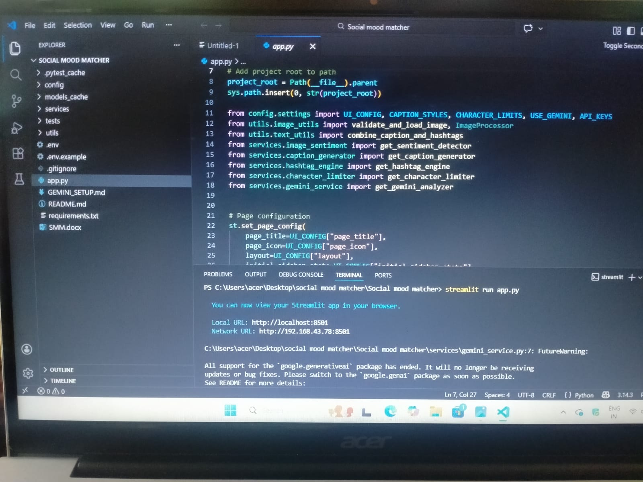

Coding for running the social mode matcher program

OUTPUT:
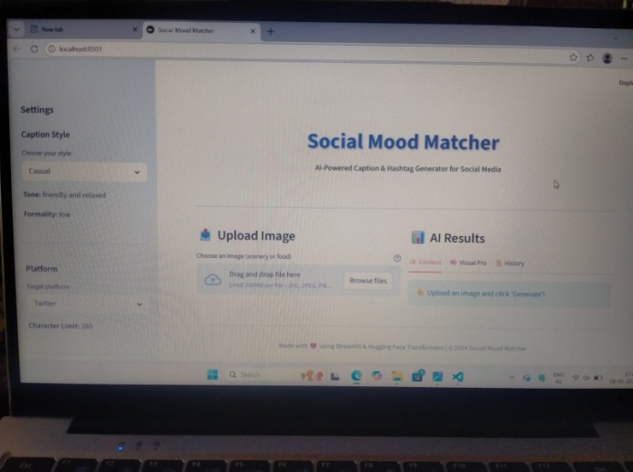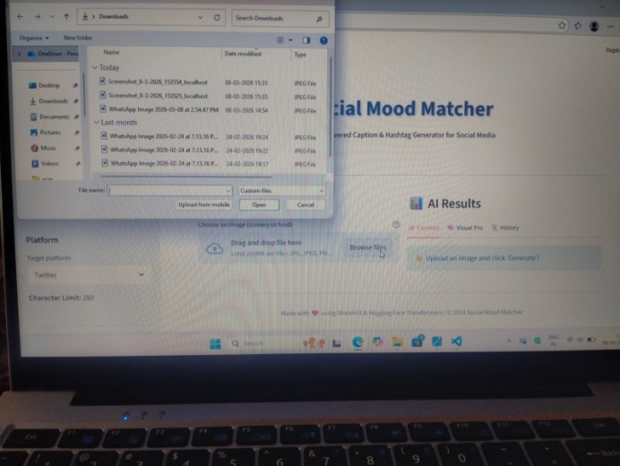
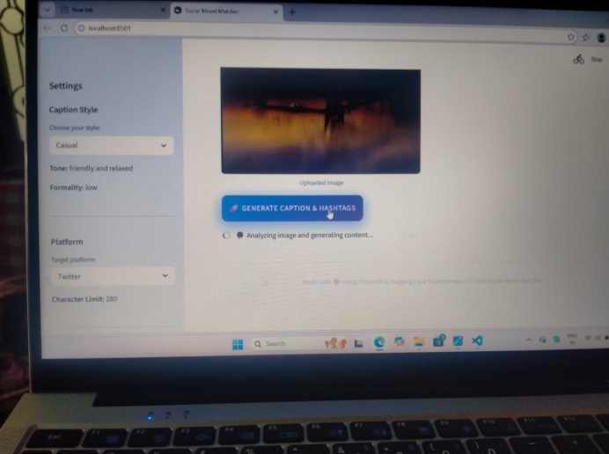

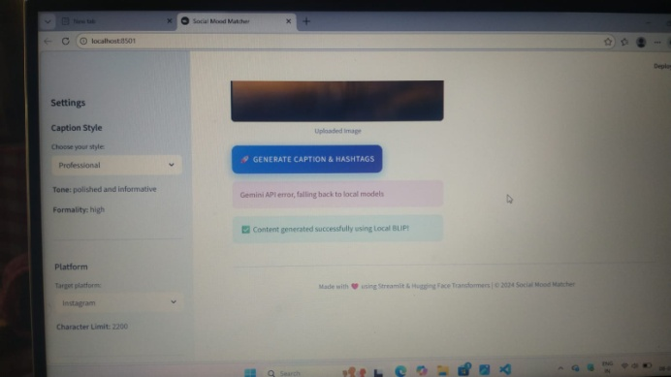

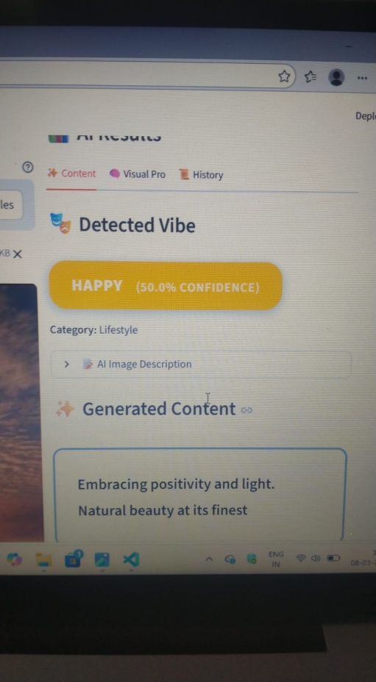
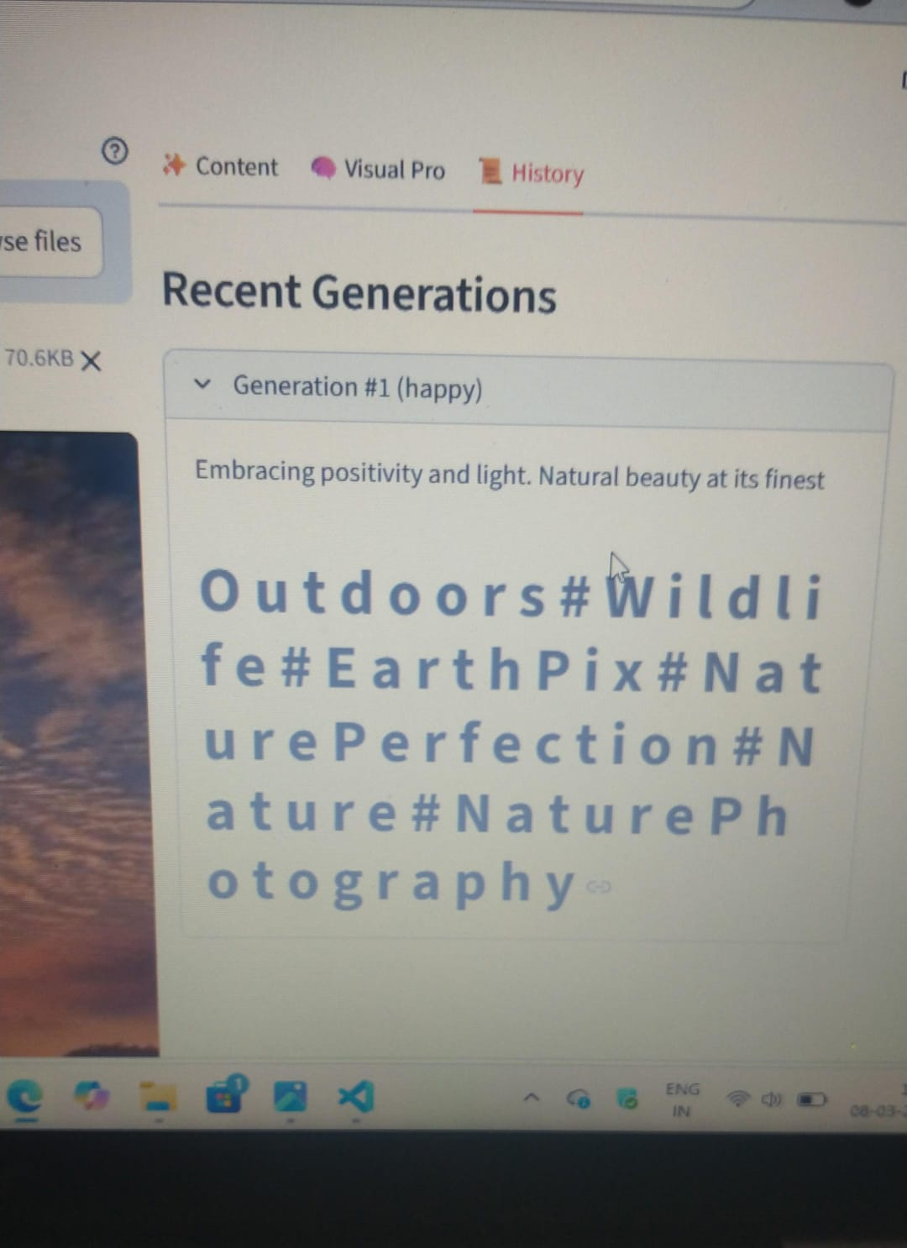

In my project, I worked on the image analysis feature.
I uploaded a scenery image into the system.
The image contained natural outdoor elements.
The system started analyzing the uploaded image.
It used an AI-based model to understand the image content.
The model detected different objects and environments.
After processing the image, the system generated results.
The output showed that the image belongs to the outdoor category.
It also identified wildlife-related elements in the image.
The system recognized the image as part of the Earth environment.
It further classified the image under nature perfection.
The model also tagged the image as nature.
Another tag provided was nature photography.
These tags help in understanding the mood of the image.
The system converts visual content into meaningful labels.
This helps users understand what the image represents.
The project successfully detected environmental features.
The analysis process was completed automatically.
The output was displayed clearly on the screen.
The system also generated a short descriptive text.
This text explains the mood and environment of the image.
The project demonstrates the power of AI in image recognition.
It helps identify emotions and themes from pictures.
The scenery image mainly reflected calm and natural beauty.
The generated tags matched the image content correctly.
This shows that the model works effectively.
The feature can be useful for social media analysis.
It helps categorize images based on mood and environment.
This makes the project more interactive and intelligent.
Overall, the experiment successfully produced accurate results.

